***Exploratory analysis***

1. ***Transaction amount VS week graph***

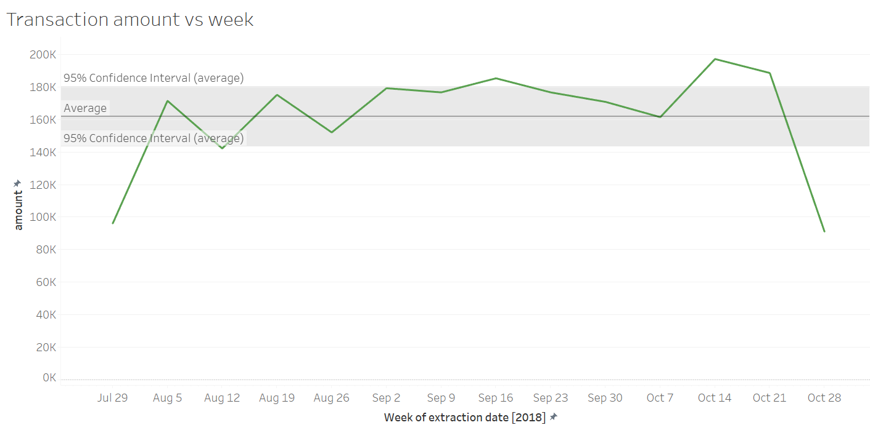

* This tells about average transaction amount per week =160k(AUD) in 3 months and also shows confidence bound of 95 percent.
* Most active transaction week was from 7- 14 October after which downfall was noticed.

1. ***Transaction amount vs age graph***

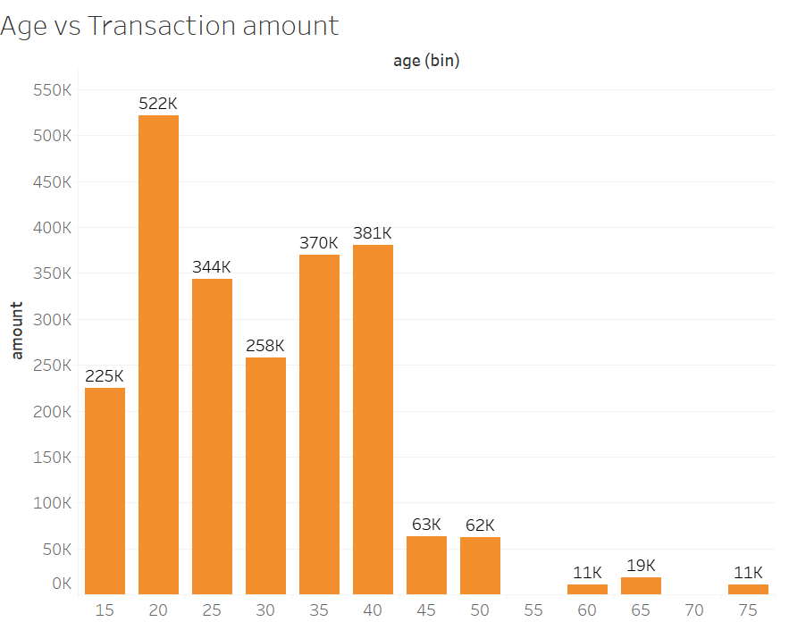

* Age of 20-25 gap shows highest transaction amount of 522K(AUD).
* And above age 45 transaction amount reduces significantly.

Note: y axis shows aggregated amount of all customers

***3.Account balance vs age graph***

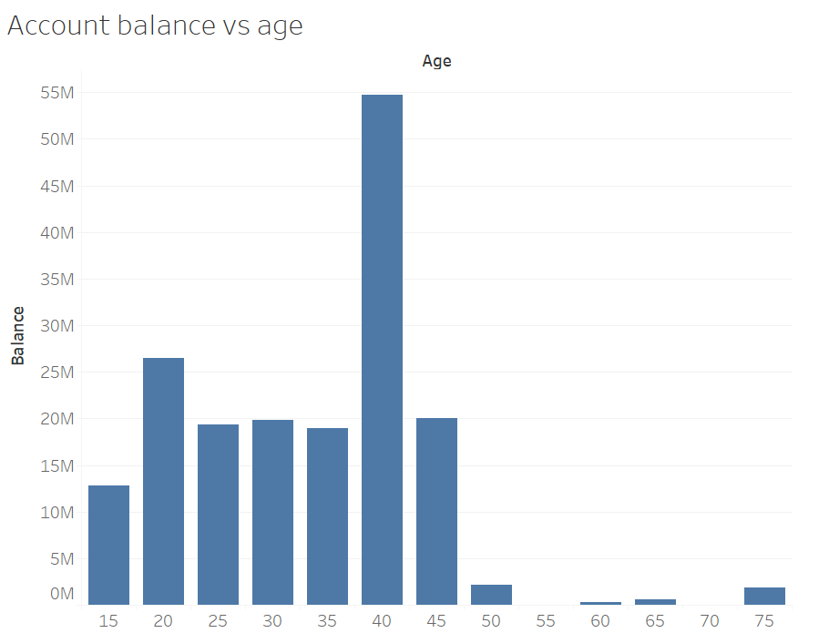

* Age 40-45 shows highest balance in account of approx. 55M(AUS) assuming rich section of the customers.
* Until 35 age average amount of balance is about 20M.
* Older age section above 50 shows lack of balance compared to others.

NOTE:(all this are aggregated amount of all customers in that age range )

**4.Transaction amount vs time of extraction**

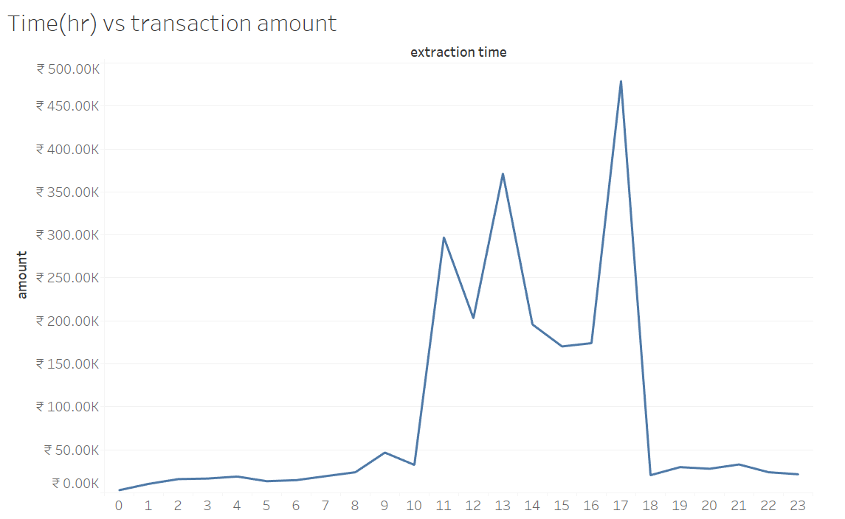

* Most active hour of transaction was 17HR with most transaction of 475k(AUD).
* Least active hour ranges from 0-10 and 18-23HR.

***5.Clustering( Age vs Transaction date)***

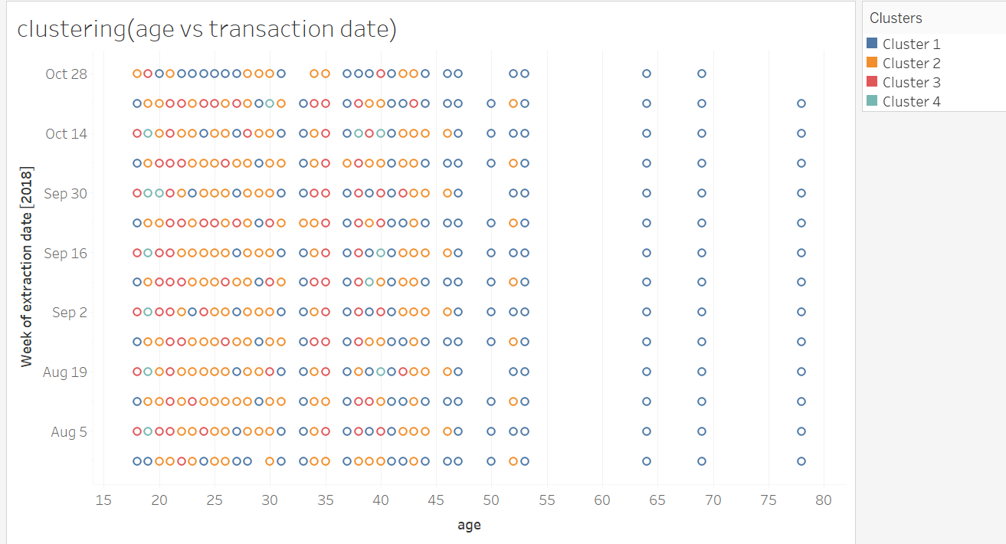

* Tableau automatically detected 4 clusters for this graph.
* Blue cluster is overall spread with most number, yellow cluster heavily clustered till age of 45,red cluster is near 20-30 range and green cluster with least number situated rarely in between.

***6.Geographic segmentation***

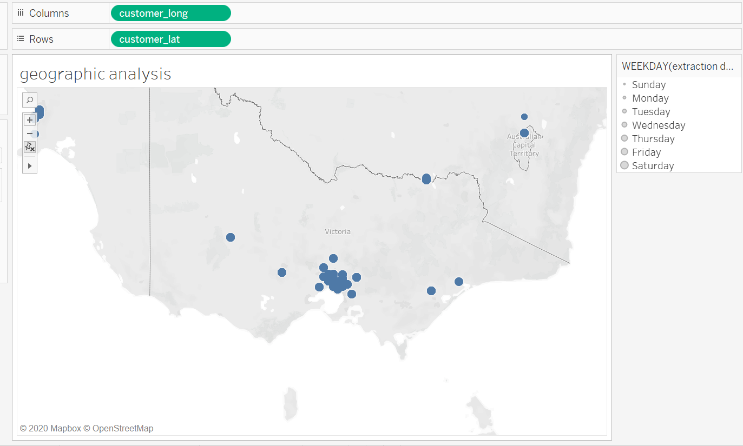

* Most of the customers are situated in south side.
* And as per extraction per day in a week circles are located.